**Ansible Task-1**

1. **Watch ansible-01 video and write down notes.**
2. **Setup one master and two worker nodes in ansible.**
3. **Execute the adhoc command shared in #dvps-cloud-documents-14 Channel.**

**---------------------------------------------------------------------------------**

1. I have completed watching the video and taken notes.
2. Create 3 Instances
   1. Ansible controller
   2. Worker 1
   3. Worker 2

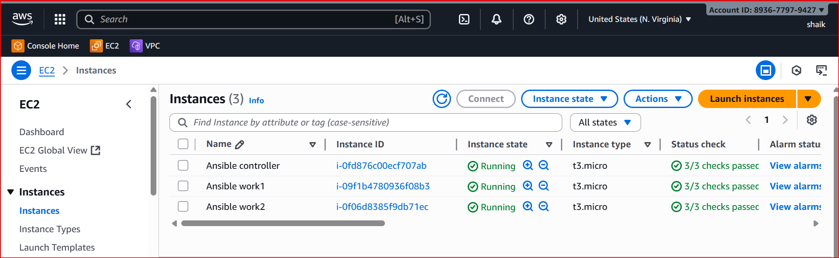

In ansible controller install ansible

apt install ansible

ansible –version

check the configuration file, If it is not available create one directory

# Create ansible directory

sudo mkdir -p /etc/ansible

# Create inventory file (hosts)

sudo nano /etc/ansible/hosts

[master]

192.168.1.10

[workers]

192.168.1.11

192.168.1.12

Create one more directory

nano /etc/ansible/ansible.cfg

[defaults]  
inventory = /etc/ansible/hosts  
host_key_checking = False  
retry_files_enabled = False

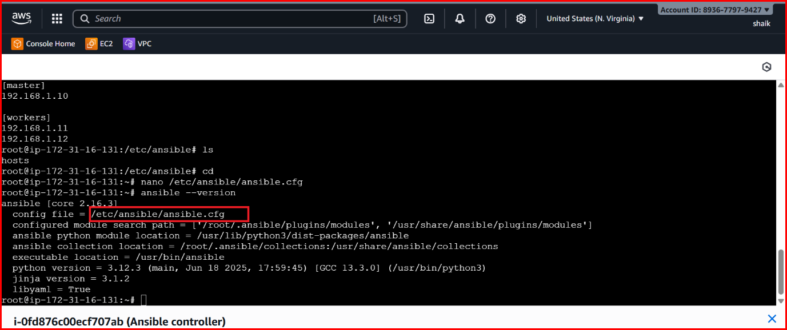



Vi hosts

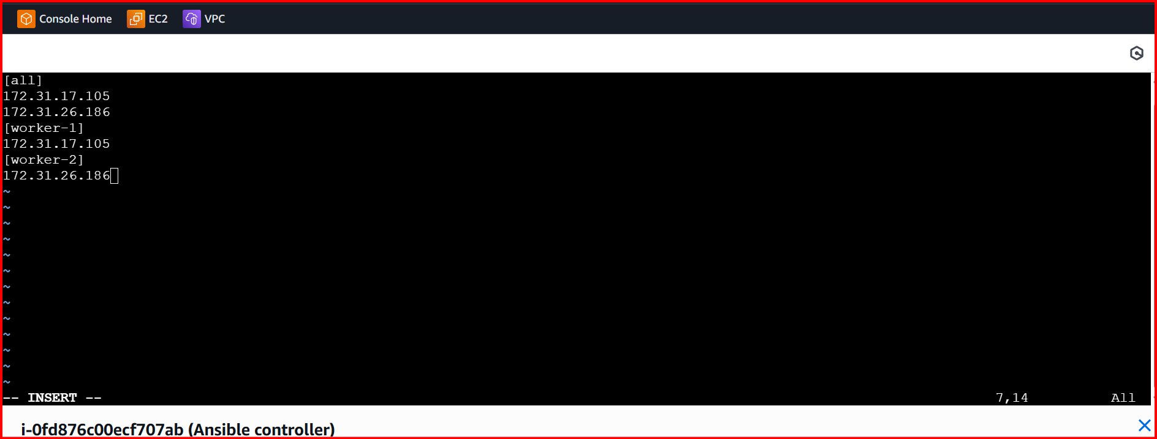

Error

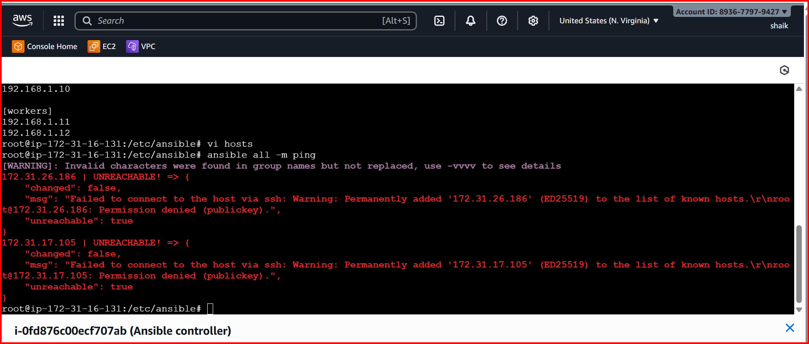

Password less authentication

Ssh-keygen cat public id

Cat public path

Copy the key

Login to worker-1

Cd .ssh/

Vi authorized_keys

Past the key

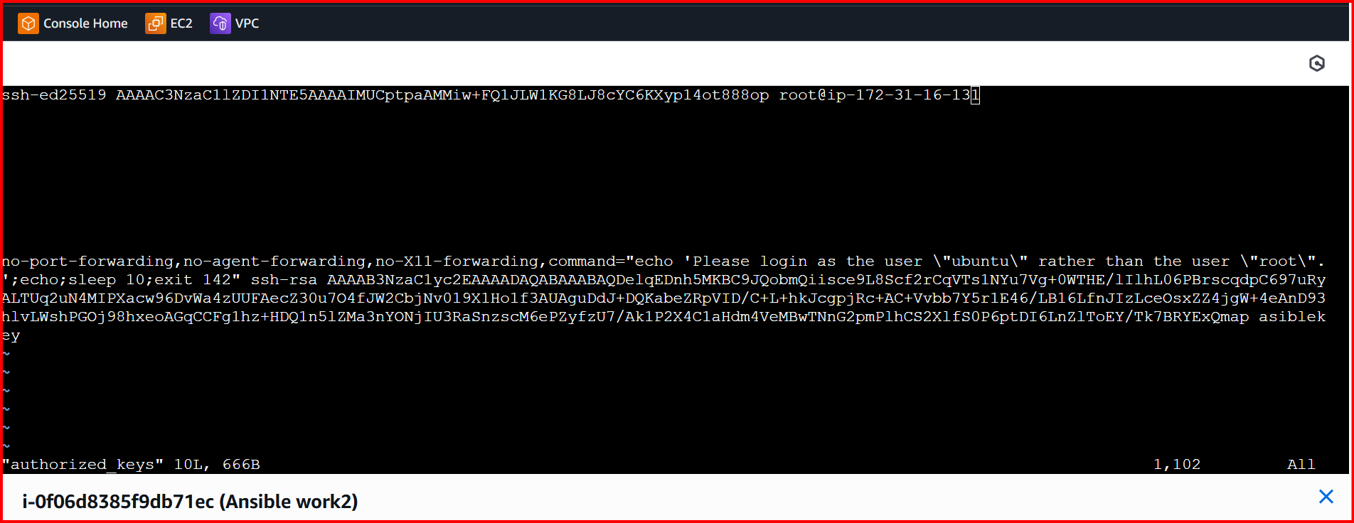

For testing

Login to main server ssh root@privateid

Repeat the same for 2rd worker machine

Form main machine execute the command ansible -m ping

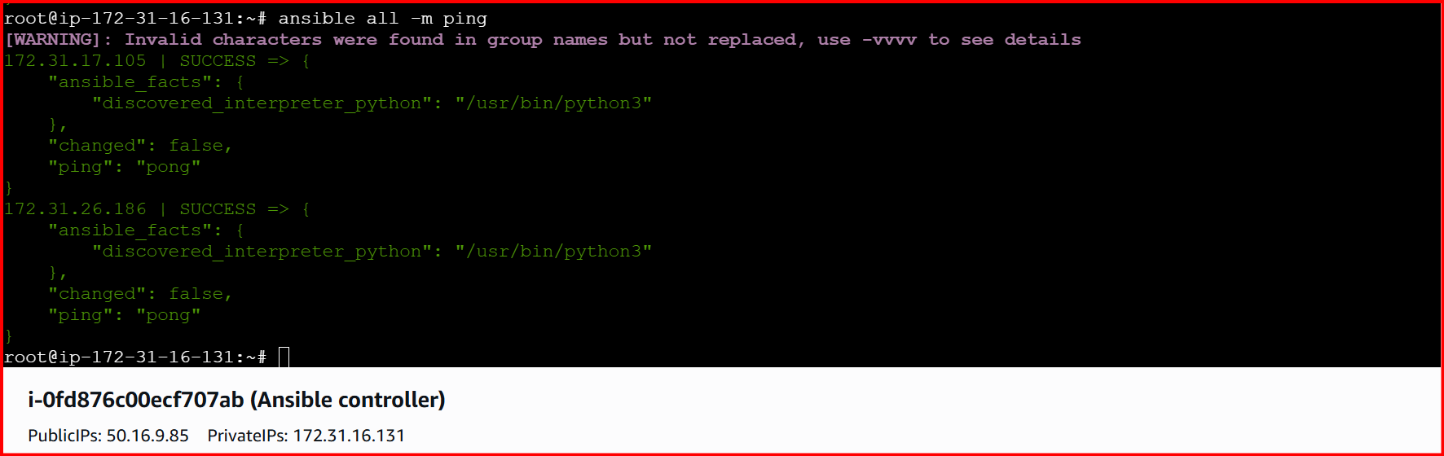

If you want to check only one work-1  
ansible worker-1 -m ping

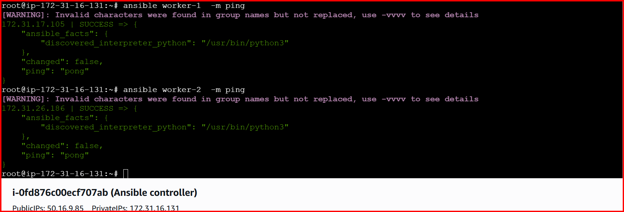

ansible worker-2 -m ping -vvvv

this command will show all the log files in detailed

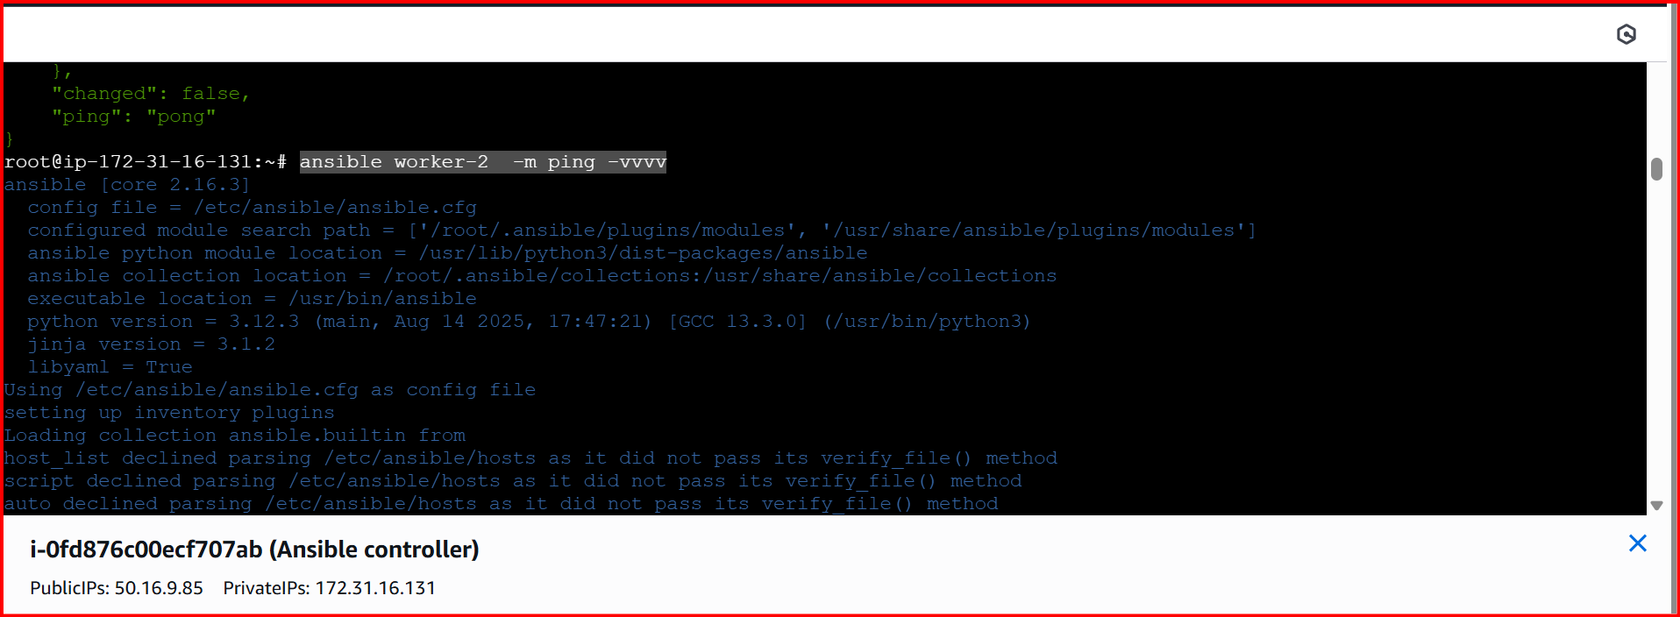

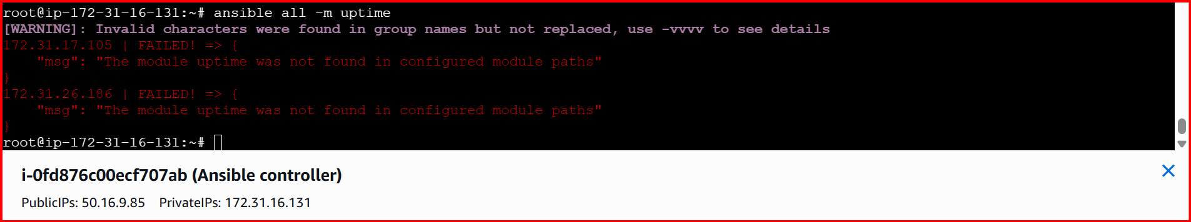

Shell is kind of module to execute the commands

ansible all -m shell -a uptime

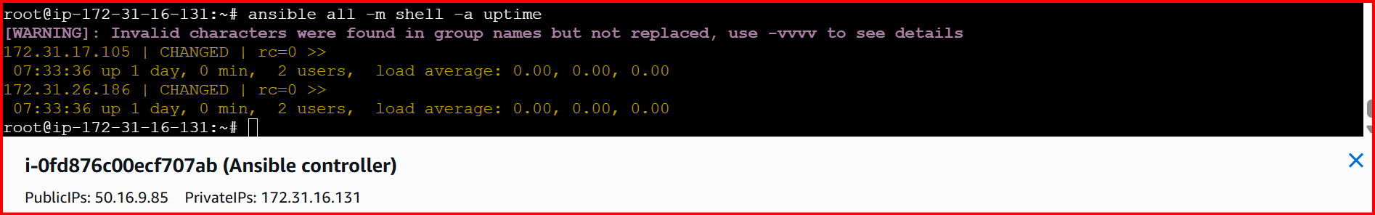

Create a directory

ansible all -m shell -a "mkdir Ansible-Shaik"

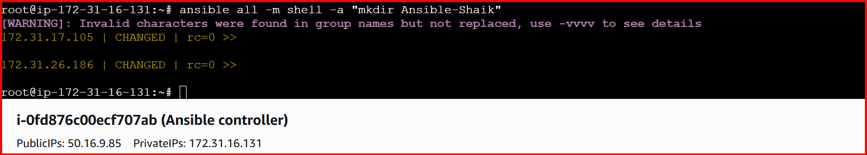

In both the servers the directory is available

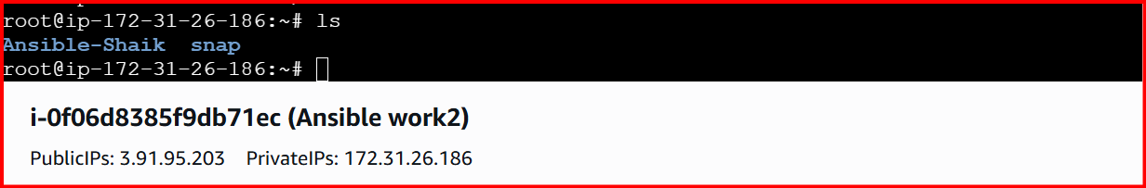

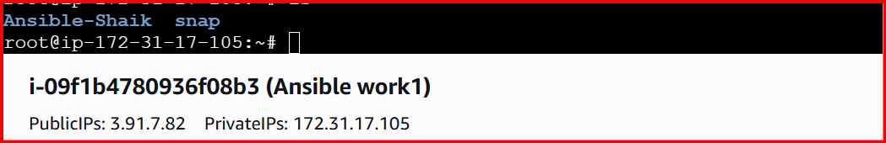

ansible all -m shell -a “ps -ef” running service

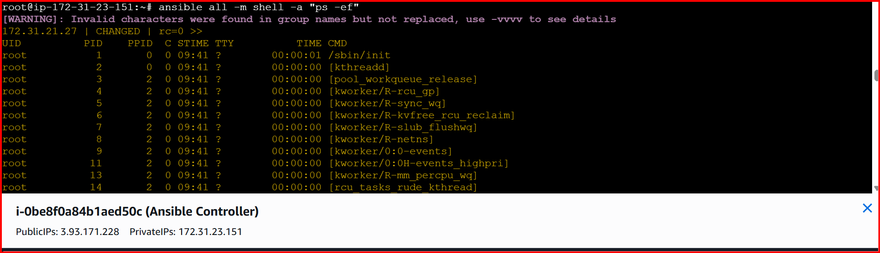

ansible all -m shell -a "mkdir Ansible-Shaik"

If you run the same command again it will fail

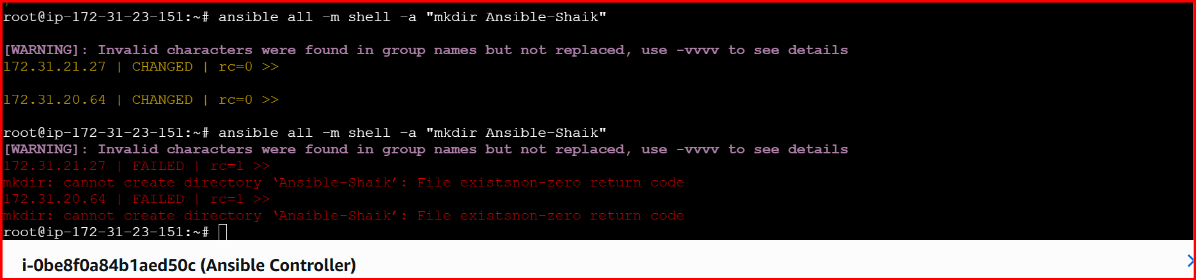

Created one inventory in root location

Yunus_inventory

Touch yunus_Inventory

Vi Yunus_inventory

[Yunus]

Private ip 🡪 Save

Command to run this inventory

Ansible -I {inventory} /root/yunus_inventory yunus{group} -m {module} ping

ansible -i /root/yunus_inventory yunus -m ping

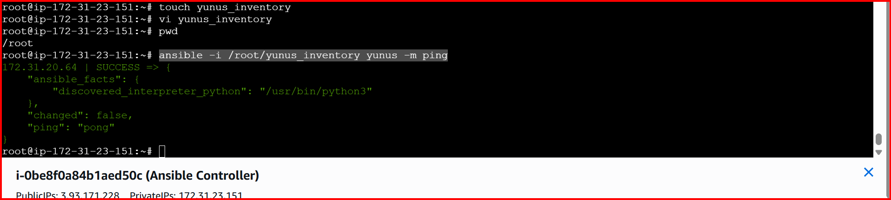

ansible all -m setup

Gather facts of slave machine 🡪 this will collect all the information related to Ec2

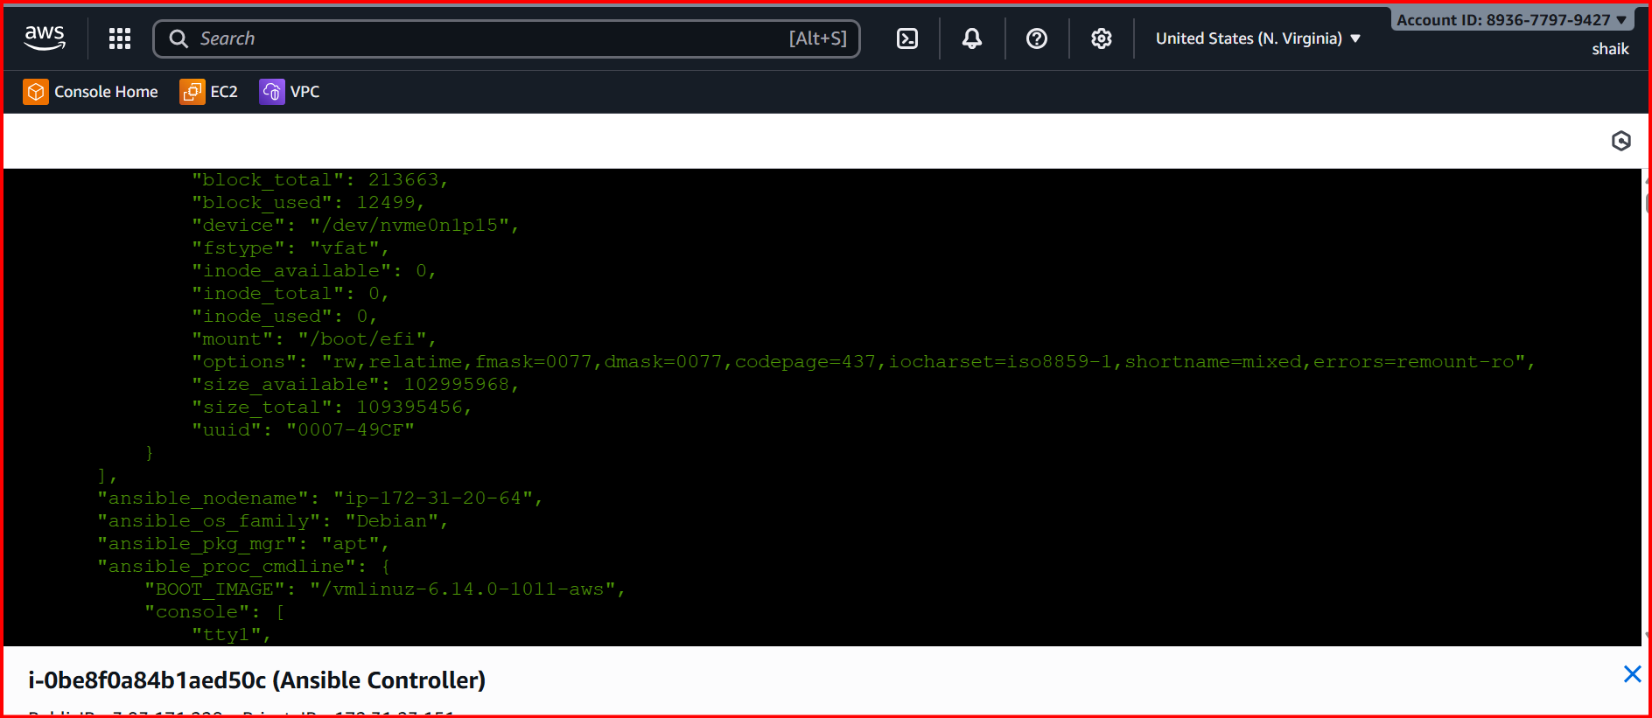

ansible all -a "free -m"

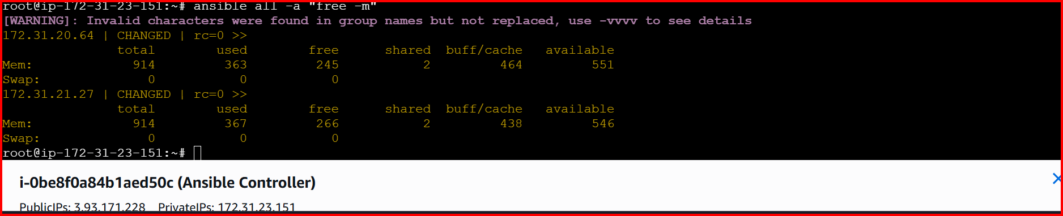

ansible all -m shell -a "apt update -y"

to update the machines

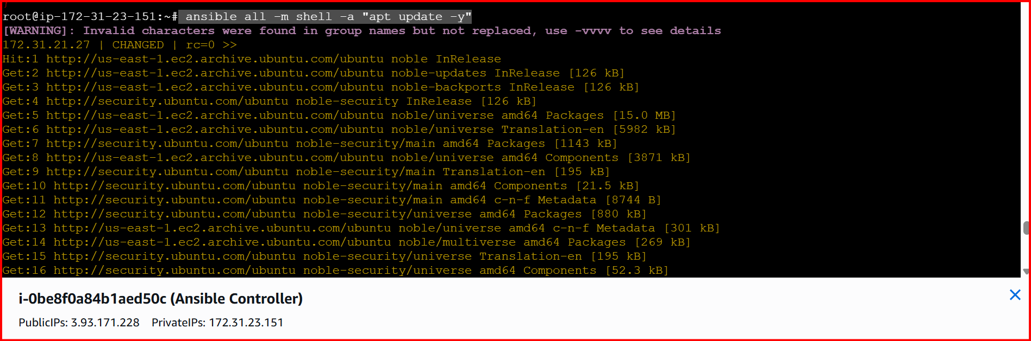

ansible all -m apt -a "name=apache2 state=latest"

installed apache2

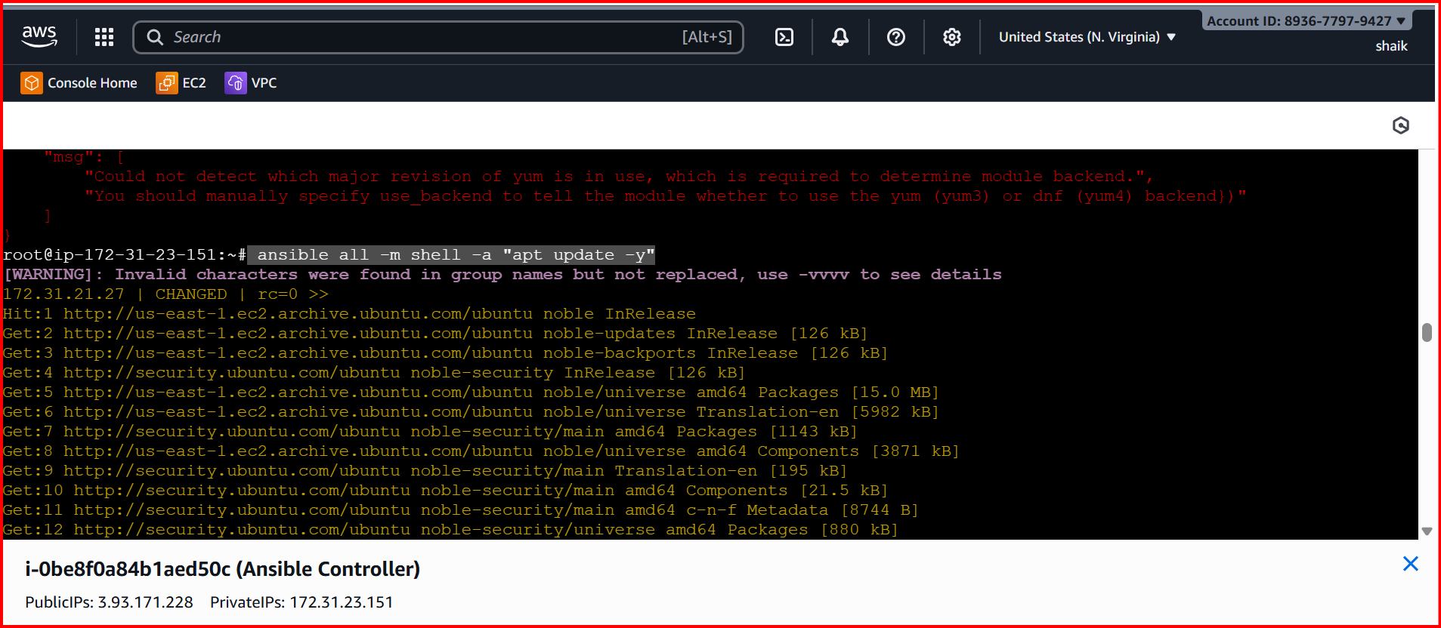

Check your worker servers

